Project 1 - Building an HTML CV/Resume

Instructions
- Answer the below question in the boxes if needed.
- For coding exercises, code on your computer and zip all your code before submission.
- Please submit the assignment after you finish.

Part 1: Creating HTML
Steps:

- We are going to make an HTML CV using just HTML. Create an HTML file named “cv.html” and add the necessary skeleton (as shown in Chapter 1 or Lab 1).

- Add your name in the CV or the name below. Add an email link where clicking the link prompts you to send an email to the highlighted email address.
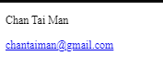

Part 2: Experience and Education

- Create an experience section. Note that all headings should be in bold and of varying text size (No CSS allowed).
- Add a table showcasing all the educational experiences and another table showcasing all your other professional experiences. You may follow the format like the one below or come up with your own format. (Hint: feel free to Google for some CV template and see how people are structuring their CV)
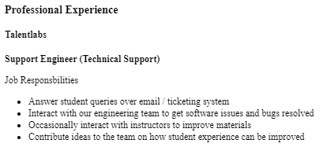

Part 3: Other Sections
- Add additional sections such as skills, awards received, certificates, etc. You can also add some images to your CV (e.g. your profile picture). You can decide what are the sections that you want to include or exclude.
- You may refer to the full CV template on the below to have an idea on how your CV should look like. You can also refer to this link(https://resume.io/uk/cv-templates/simple) for more CV design and structure. Don’t worry about the colors and styling in this project as we are going to work on those in the next project.

